Consultation on Changes to the

Mental Health Code of Practice -

Restraint and Seclusion in Hospital



Easy Read version

Introduction

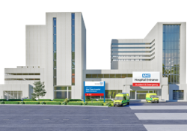
This document explains restraint and seclusion in hospital. It explains what they are, when they can be used and what your rights are. Restraint and seclusion should only be used as a last resort.


Restraint means stopping someone from moving freely. This can include:
- staff holding a person
- equipment used to restrict movement
- medication to control behaviour

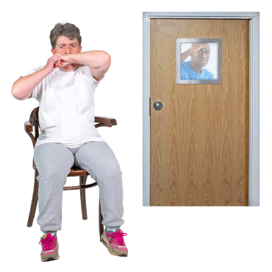
Seclusion means keeping someone alone in a room or space. Seclusion should only be used for detained patients. It is only used to stop harm.

Detained means not allowed to leave hospital because of mental health law.

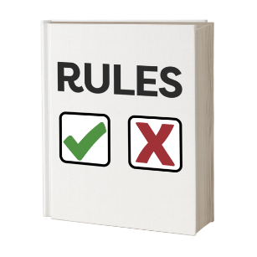
Rules explain how people should be treated when they are in hospital. The law says they are for everyone.

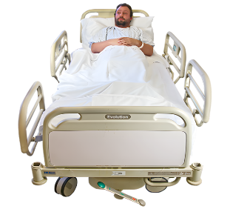
This is for:
- patients in hospital

- families and carers
- named persons and advocates
- staff who support patients

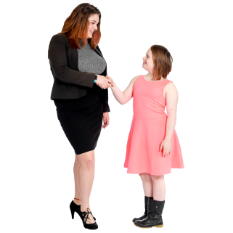
You have the right to:
- be treated with dignity and respect
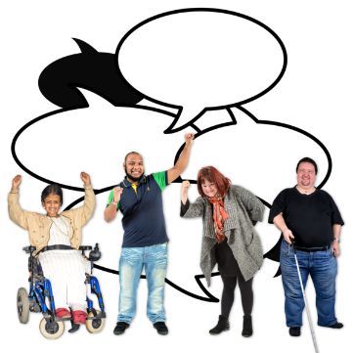
- be kept safe
- have your views listened to
- get help from an advocate

Future care planning
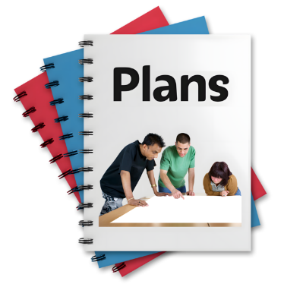
Planning ahead can reduce stress. Plans should:
- be made with the person
- involve families and carers if ok to do so
- say what helps and what to do early

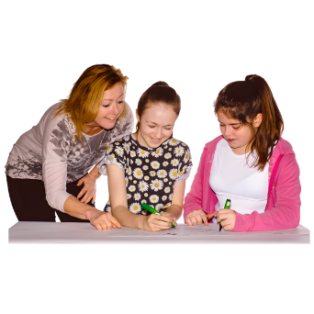
Children and young people need extra protection. Restraint and seclusion should not be used often.


A child or young person’s best interests must always come first. The United Nations Convention on the Rights of the Child says this must happen. It also says children and young people should be restricted as little as possible.

The United Nations Convention on the Rights of the Child lists the rights of children and young people. It protects them. It must be followed.


Autistic people and people with learning disabilities may show stress differently. Behaviour is usually a sign of unmet need, not bad behaviour. Disability is not a reason for restraint.

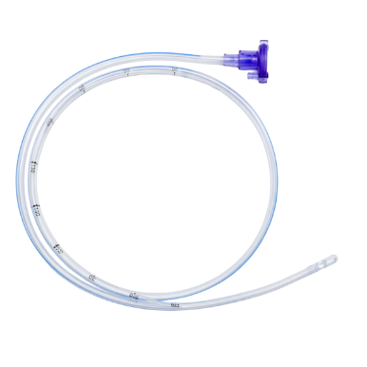

Feeding through a nasogastric (NG) tube means putting food into the stomach using a tube through the nose.

Most people will not need restraint for NG tube feeding. Forced feeding is not allowed.
Restraint should only be used if:
- there is serious risk to life or health
- all other ways of helping have been tried

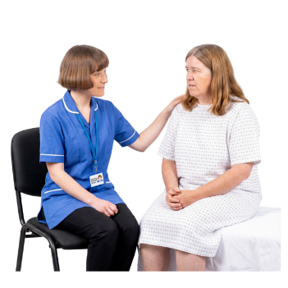
After NG tube feeding with restraint:
- the person should be supported and checked
- staff should explain what happened
- what happened should be checked over to reduce future use

Checks

When restraint or seclusion is used:

- staff must record what happened
- staff must check the person is safe
- the service should learn from what happened


Health Boards and staff should follow national rules set by the Mental Welfare Commission. It is a government service that supports people with mental illness.

Staff planning and training
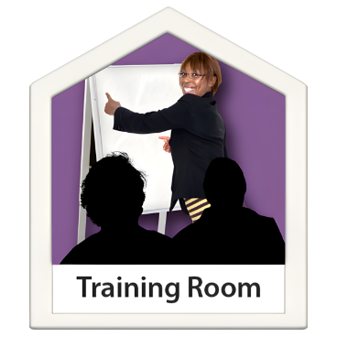
Staff must be trained and supported.
Staff:
- must be trained to calm situations safely
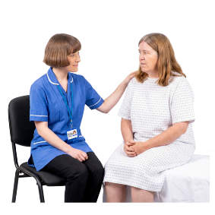
- must understand trauma, children and disability
- should get support after incidents

You can ask for help from:

- an independent advocate
- hospital staff
- carers or family

- the Mental Welfare Commission
 | What do you think about this?

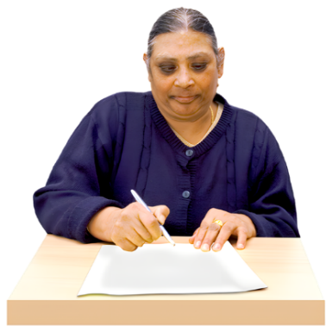 | You can write what you think on the page below.

