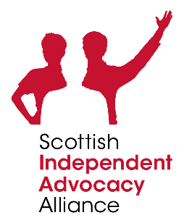

SIAA AGM & Safeguarding Independent Advocacy (Nov 30)
Possible outcomes for framework

- SIAA membership developed these IA national outcomes at the SIAA Conference (Nov 30).
- A drafting group with members from different independent advocacy organisations will continue the work on these to then share for further comment with members. Members put their names forward at the event on Wednesday and from this a representative working group will be formed.

 | Possible outcomes
Advocacy partners (individuals or groups) | - Advocacy partners feel more able to have their views and wishes taken into account.  - Advocacy partners are better informed of their rights.  - Advocacy partners have more choice and control in situations which affect their lives.  - Advocacy partners who have more limited capacity are more able to have their rights safeguarded.  - People will feel more listened to and seen.  - People will have increased awareness and understanding of rights and options.  - People will have increased confidence and control (redressing power imbalances).  - People will feel they are treated with more dignity and respect.
Service providers | - A greater emphasis on trained and skilled staff.  - Greater awareness of human rights and ability to exercise these rights.  - Increased participation in decision making processes.  - More people can access services at the right time.  - Independent advocacy credibility and legitimacy is recognised and fully understood.  - Independent advocacy helps to defend and uphold human rights.
Wider community | - Human rights upheld for all, strong community voice.  - Reduction of stigma in communities using education.  - Improved services with equality of access.  - Empowered community with strong connections.  - Scotland knows what advocacy is and expects it to be on offer.  - Scottish citizens have empathy and understanding of everyone’s rights.  - Scottish citizens know what we do, don’t do, how we do it and why we do it.  - Scottish citizens are supported to decide whether to use independent advocacy or not.

