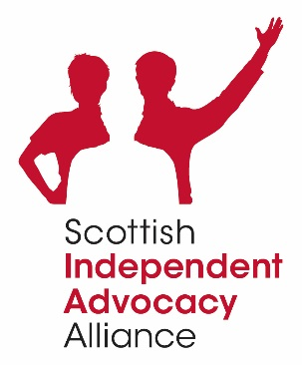

**Scottish Independent Advocacy Alliance**

**Board of Directors**

**Structure 2022**

|  |  |  |
| --- | --- | --- |
| **Type of Member** | **Allocated Seats** | **Vacancies** |
| Full | 12 | 4 |