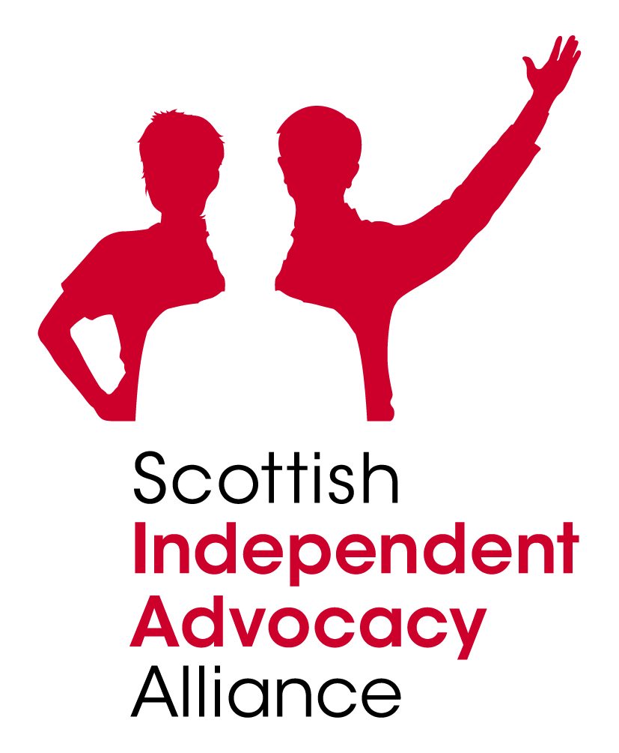

Scottish Independent Advocacy Alliance

AGM – 30 November 2022

Board Member Nomination Form

Name
Organisation
Position in Organisation
Address
Postcode
Telephone
E-mail (Please Print)

Nominated by:
(if applicable)

I confirm that I have the agreement of the Management Committee/Board of the above organisation for this nomination.

Signature
Date

Please return to: - Scottish Independent Advocacy Alliance enquiry@siaa.org.uk by 12 pm on Monday 24 October 2022

