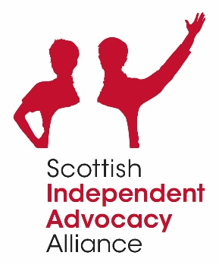
Scottish Independent Advocacy Alliance
Role of the Board of Directors 2022

Mission Statement
The Scottish Independent Advocacy Alliance (the SIAA) promotes, supports and defends the principles and practice of independent advocacy across Scotland.
It does this by:
- Providing a strong national voice for independent advocacy organisations.
- Supporting the growth of existing independent advocacy organisations.
- Promoting the development of new independent advocacy organisations.
- Encouraging existing advocacy organisations towards independence.

General Responsibilities of the Board of Directors
The role of the Board of Directors is to work as a team to ensure due diligence and integrity, , to provide governance and to work in partnership with the CEO to achieve the aims of the SIAA.

The Main Duties of Board Members
- To ensure that the SIAA conducts its business in accordance with its Constitution, Memorandum and Articles of Association and in adherence with relevant legislation.
- To govern the organisation within best practice frameworks.
- To attend Board meetings (and relevant sub groups) regularly and contribute actively to the role of the Board in determining strategy, approving policy and monitoring performance.
- To ensure that the organisation’s resources are deployed in such a way as to ensure the SIAA meets its objectives and that the SIAA’s finances are systematically accounted for, audited and made publicly available.
- To oversee the management of the SIAA and future development of the organisation.

- To promote effective relationships between Board members and staff, member organisations, other advocacy organisations, the Scottish Government and others who are important to the organisation and independent advocacy in Scotland.
- To participate where appropriate in the recruitment of staff.
- To safeguard the ethos of the organisation and to promote the organisation and its work, along with fellow Board members and staff, to existing and potential funding agencies and relevant others.
- To contribute any specific skills, knowledge and experience to assist the Board of Directors reach sound decisions.

Skills, knowledge and experience of individual Board Members
The SIAA may require different skills; knowledge and experience from Directors at different times and therefore the SIAA expect Directors to bring:
- A clear vision of the SIAA’s aims and objectives and understanding of the role of the SIAA.
- An ability to think strategically.
- A clear understanding of the role of the Board.
- A clear understanding of good practice regarding governance.
- Time and interest to devote to the Board and the responsibilities of the Board - to read Board papers in advance of meetings and regularly attend Board meetings which will be held on a quarterly basis; and to attend and actively participate in sub groups and working groups.
- An interest in keeping up to date and informed about the SIAA’s activities.
- Ability to contribute to meetings and to the SIAA’s leadership and direction, accountability and development in a relevant and constructive way.
- Knowledge about independent advocacy and commitment to its principles and standards.

