Social media kit for members

SIAA has produced content for social media aiming to highlight the importance of independent advocacy. We have published this social media kit for members, to make it easy for you to share the information on your own channels.
We believe we are stronger together and sharing the same content can have a powerful impact on people's awareness of independent advocacy and understanding of how it can empower people and ensure people’s human rights are recognised, respected, and secured.
The posts are organised in different series, based on the topic they cover. However, we would encourage you to use the content as wish!

You can also tag us on Twitter: @siaa_voice

Series | Suggested posts
Introduction to independent advocacy | What is independent advocacy?  - Who can access independent advocacy?  - How can I find an advocate?  - Independent advocacy and human rights
Principles, standards & code of conduct | - Principles’ introduction  - Principle 1  - Principle 2  - Principle 3  - Principles in action
Types of independent advocacy | - Types of independent advocacy  - Individual advocacy  - Collective advocacy

Series: Introduction to independent advocacy
1. What is independent advocacy?
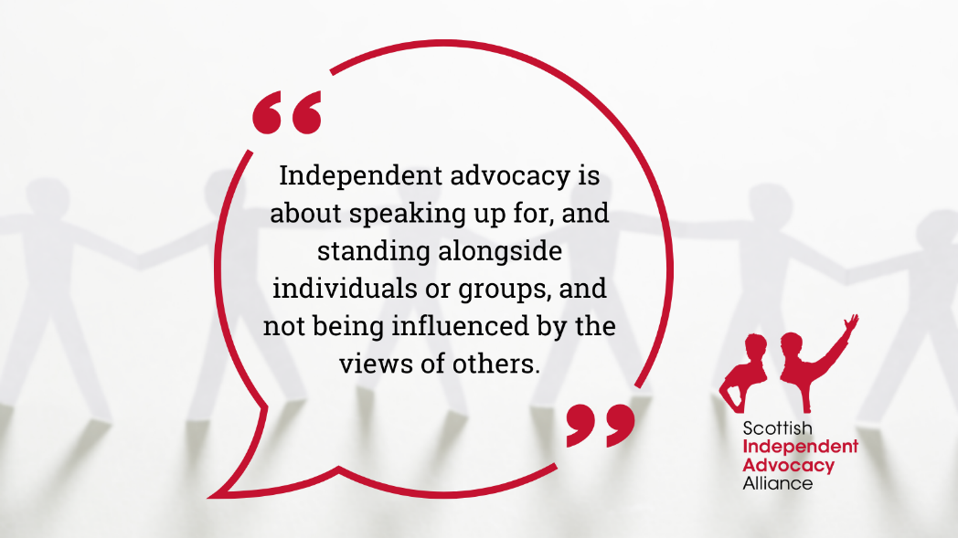
Independent advocacy:
✅ Empowers and helps people have a stronger voice.
✅ Addresses barriers and imbalances of power.
✅ Ensures that an individual’s rights are recognised, respected and secured.
Find out more on @siaa_voice website: ➡️siaa.org.uk/what-is-independent-advocacy/

2. Who can access independent advocacy?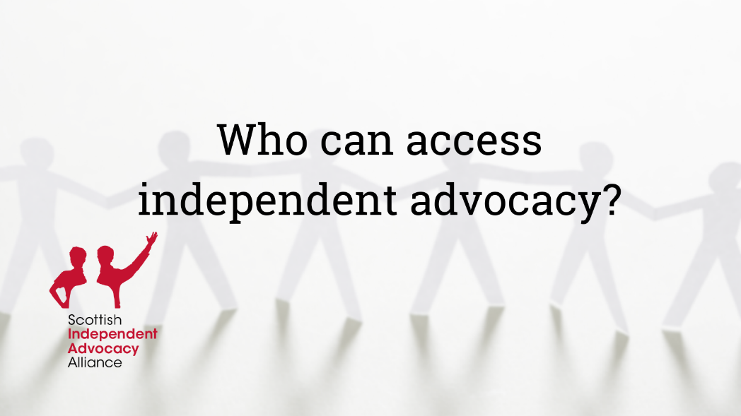
Did you know that there are only a few groups of people that have a right of access to independent advocacy enshrined in Scottish Legislation? 🤔
As members of SIAA @siaa_voice, we work towards widening access to independent advocacy in Scotland.
➡️siaa.org.uk/what-is-independent-advocacy/faqs/

3. How can I find an advocate?
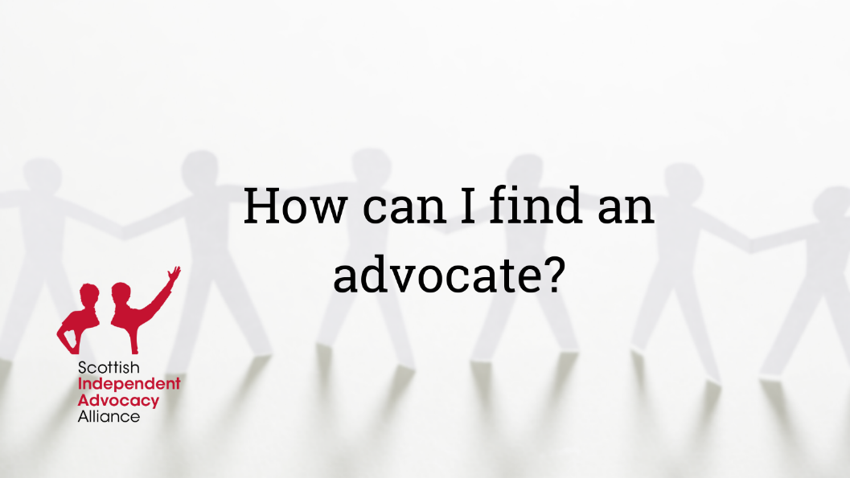
🔍 Looking for independent advocacy?
Check out @siaa_voice ‘Find an advocate’ tool to access clear and accessible information
about independent advocacy provision in Scotland.
➡️siaa.org.uk/find-an-advocate/

4. Independent advocacy and human rights
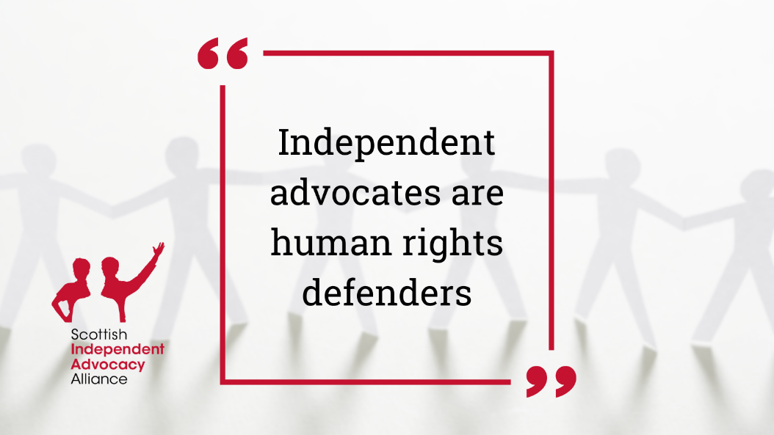
Independent advocates are human rights defenders.
Independent advocacy plays a key role in helping to ensure that an individual’s human rights are respected by offering access to justice on an equal and non-discriminatory basis with others. ⚖️
➡️ siaa.org.uk/what-is-independent-advocacy/independent-advocacy-and-human-rights/

Series: Principles, standards & code of conduct

1. Principles’ introduction
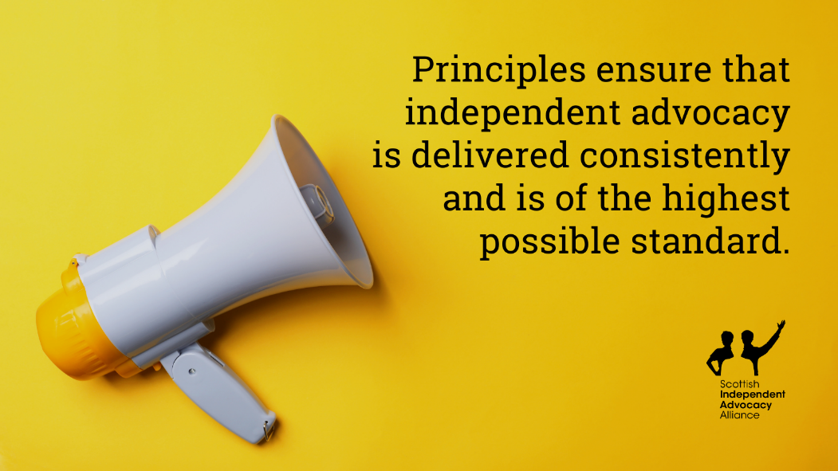
❓ Did you know that all SIAA members share the same principles?
This is to ensure that independent advocacy is delivered consistently and is of the highest possible standard.
Find out more: ➡️siaa.org.uk/information-hub/principles-standards-code-of-best-practice/

2. Principle 1
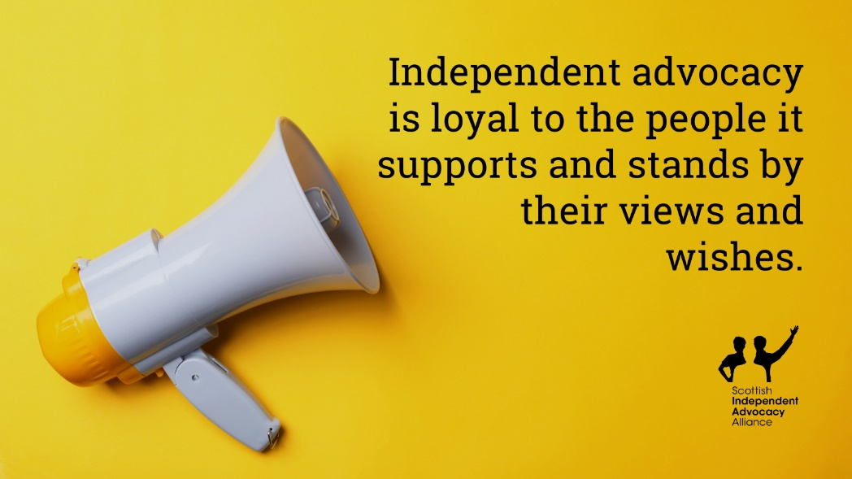
📢 Principle 1: Independent advocacy is loyal to the people it supports and stands by their views and wishes.
To do so, there are different standards underpinning this principle. Find out what these standards are:
➡️siaa.org.uk/information-hub/principles-standards-code-of-best-practice/

3. Principle 2
📢 Principle 2: Independent advocacy ensures people’s voices are listened to and their views are taken into account.
Find out more about the standards linked to this principle:
➡️siaa.org.uk/information-hub/principles-standards-code-of-best-practice/
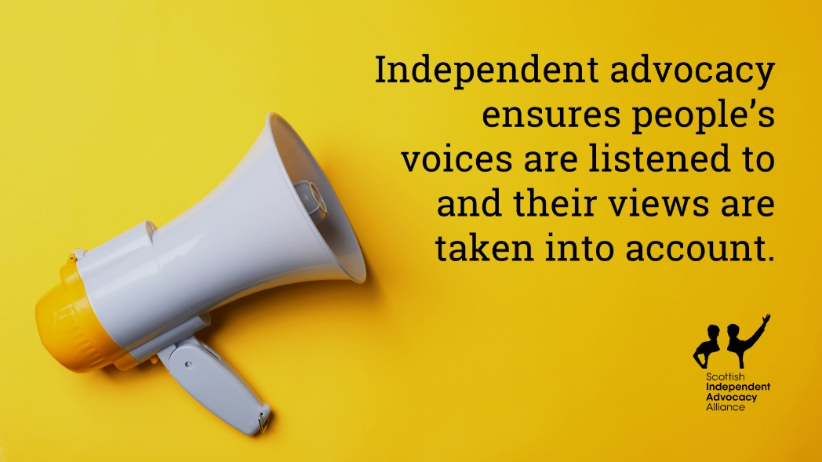

4. Principle 3
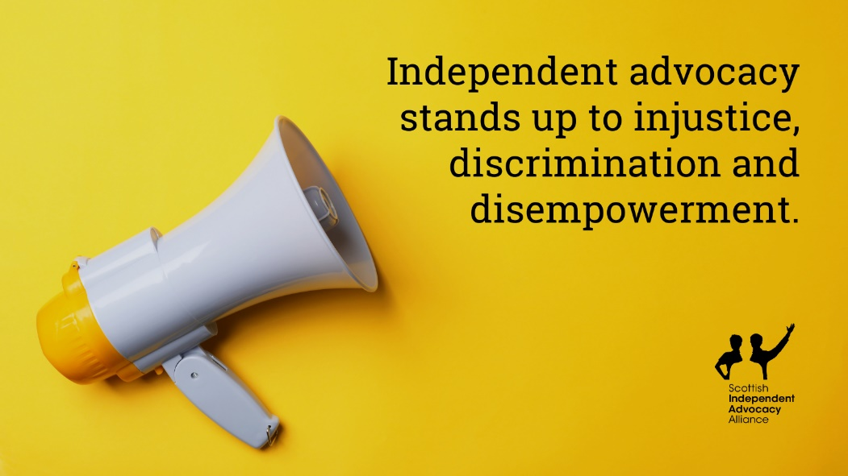
📢 Principle 3: Independent advocacy stands up to injustice, discrimination and disempowerment.
Learn about the standards linked to this principle:
➡️siaa.org.uk/information-hub/principles-standards-code-of-best-practice/

3. Principles in action
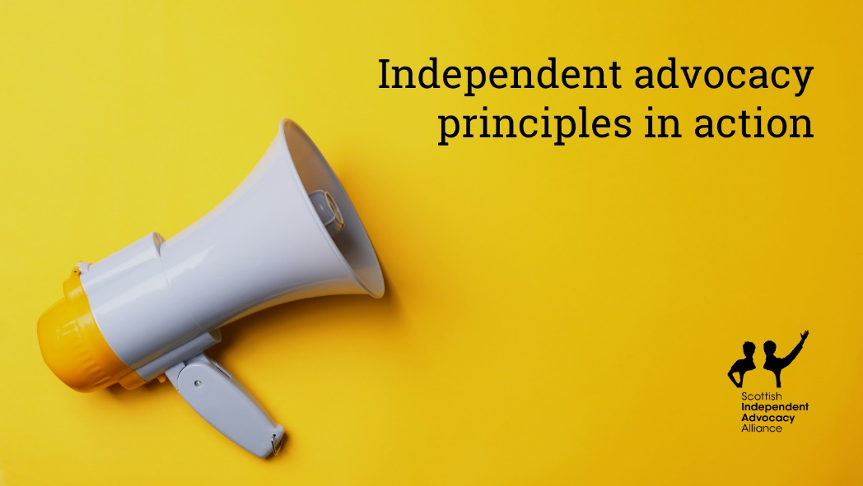
What do independent advocacy principles look like in action? 🤔
Explore the ‘Independent advocacy in action: Case studies illustrating SIAA’s ‘Principles and Standards’ to learn what these principles mean in practice.
➡️siaa.org.uk/information-hub/independent-advocacy-in-action-case-studies-illustrating-siaas-principles-and-standards/

Series: Types of independent advocacy

1. Types of independent advocacy
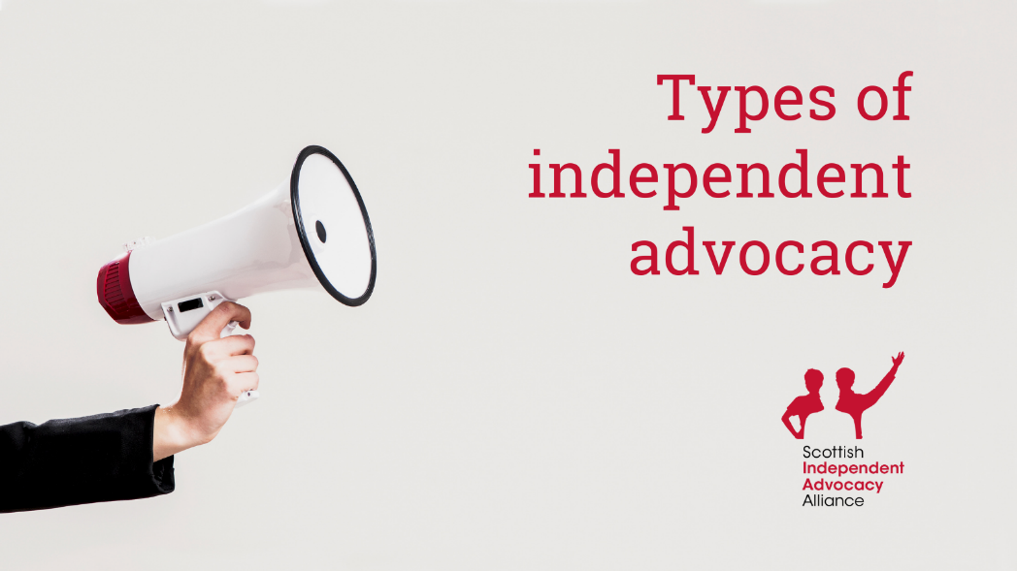
Independent advocacy has two different formats:
✅ Individual advocacy
✅ Collective advocacy
You can learn more about the different types of advocacy on our website.
➡️siaa.org.uk/what-is-independent-advocacy/types-of-independent-advocacy/

2. Individual advocacy
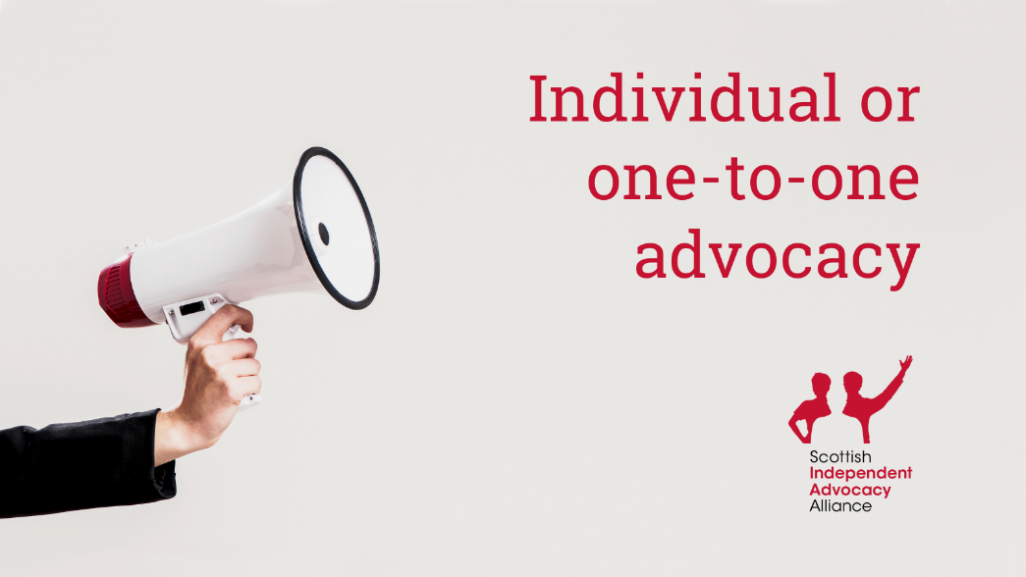
Individual or one-to-one advocacy: An advocate supports an individual to represent their own interests or represents the views of an individual if the person is unable to do so. 💬
Learn more on our website:
➡️siaa.org.uk/what-is-independent-advocacy/types-of-independent-advocacy/
Find an advocate:
➡️siaa.org.uk/find-an-advocate/

3. Collective advocacy
Collective advocacy: Collective advocacy creates spaces for people to get together, support each other to explore shared issues, and find common ground. 📣
Learn more on our website:
➡️siaa.org.uk/what-is-independent-advocacy/types-of-independent-advocacy/
Find an advocate:
➡️siaa.org.uk/find-an-advocate/

